1.REMOVE SALT AND PEPPER NOISE FROM AN IMAGE USING AN AVERAGING FILTER AND A MEDIAN FILTER

I = imread('eight.tif');
figure
imshow(I)
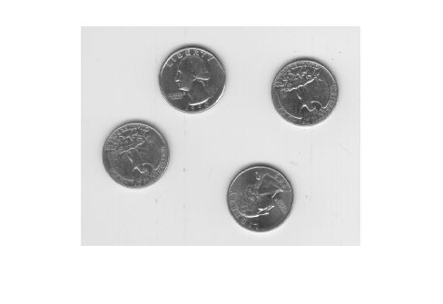
J = imnoise(I,'salt & pepper',0.02);
figure
imshow(J)
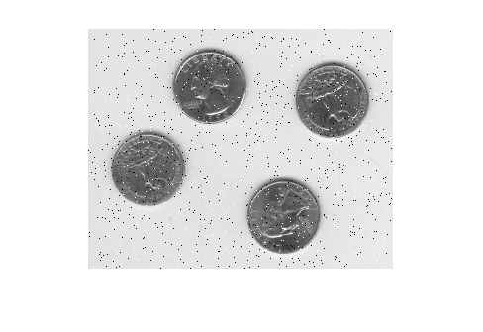
Kaverage = filter2(fspecial('average',3),J)/255;
figure
imshow(Kaverage)
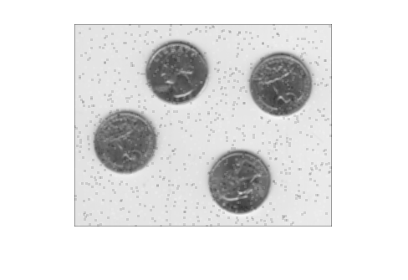
Kmedian = medfilt2(J);
imshowpair(Kaverage,Kmedian,'montage')
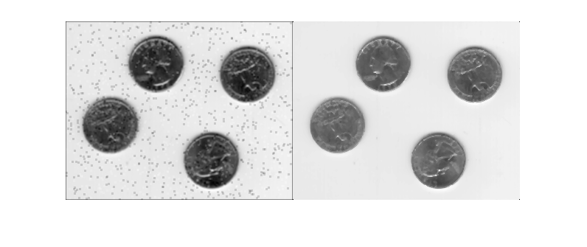

2.APPLY A WIENER FILTER TO AN IMAGE ADAPTIVELY
RGB = imread('saturn.png');
I = im2gray(RGB);
J = imnoise(I,'gaussian',0,0.025);
imshow(J(600:1000,1:600));
title('Portion of the Image with Added Gaussian Noise');
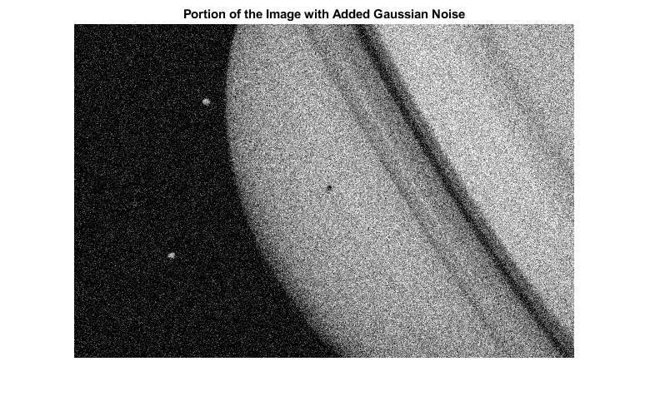
K = wiener2(J,[5 5]);
figure
imshow(K(600:1000,1:600));
title('Portion of the Image with Noise Removed by Wiener Filter');
